Partial Solution of *3xN* Chomp

Ezra Skwarka

July 2020

# The Game of CHOMP

Have you ever been eating a chocolate bar and thought to yourself, "Man this would be a lot better if it involves some complicated maths and a deadly poison" or maybe “What if I had a convenient math filled way to kill all my friends?” Well if you have, somehow you aren't alone. Also, maybe get that looked into? In fact, at least one other person, David Gale {S}, had a very similar idea.  He took a game that was originally published by Frederick Schuh {S} and modified it to be played on a chocolate bar as opposed to an abstract graph.  This game is known as Chomp.

Chomp is a two-player impartial combinatorial game of partially ordered sets. It is effectively a misère style game with the removal of the minimal element considered to be the losing condition.  Now that sounds like a lot of meaningless jargon to you, I totally sympathize because about 6 weeks ago it meant nothing to me either. That said once you break down the components of these descriptors it's actually pretty straightforward. If we break it down piece by piece, a combinatorial game is a special kind of game with the following conditions:

* there are exactly two players who take alternating turns
* there is no chance elements and all players have perfect information
* a single combinatorial game must be finite and constructed in a way that there is a definitive end to the game
* there are no drawers, the winner of the game is determined by who moves last so that does not necessarily mean the player who moves last will win

Some other combinatorial games include Chess, Checkers, Go, Nim, and Tic-Tac-Toe. Of those games, all but Nim are considered to be partizan as opposed to impartial. The difference between them can be summed up as if you have pieces that are different from your opponents like in chess it's a partisan game because you can't move your opponent's pieces. But if everyone has the same moves available look to them at all times the game is impartial.  Now if you haven't heard of the game of Nim don't worry about it too much, because while it is a very important game for understanding Combinatorial Game Theory and it itself is relatively simple, it is not the focus of this paper and you do not need to know how to play to understand the rest of this paper.

I also said that Chomp is a misère style game, this simply means whoever moves last losses, in this case that's because they eat a poisoned piece of chocolate and presumably die. I challenge anyone who says math is boring to play this game, I bet you they're tune will change. Anyway, I also said this is a game on partially ordered sets a phrase which here means sometimes the moves you make on one piece of the board will affect other parts of the board.  Now again, while posset games can be very complicated this is all you need to understand the contents of this paper.

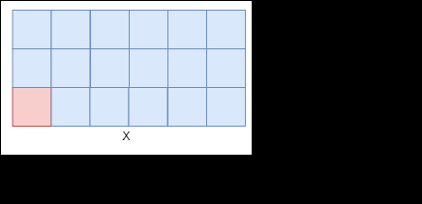

"Cool, That's great and all but how do I actually play the game?"

Figure 1

Well like I said, it's a combinatorial game which means you and your opponent will take alternating turns, so first you have to decide who's going to go first. Here's a hint, in this game you always want to go first and I'll explain why later. So the first thing we want to do is actually unwrap our chocolate bar and look at our board.

Figure 2

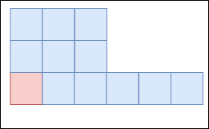If you look to the right here at Figure 1 you can see a basic 3 by 6 game board, called such because it is 3 pips high and 6pips wide with no missing pips. You might notice that the chocolate is red and blue and the picture is a little bit ugly, I just want to say thanks for reminding me that I'm not a graphic artist and just crushing my dreams. Ignoring the idiosyncrasies of the chocolate bar we can begin to examine how you would actually play with it. So the goal here is to kill your friend by making them eat the poisoned red square of chocolate so do that we want to break off some chunk of the chocolate. In order to do that we pick a single square that we want to remove and then we also remove all squares above it and all squares to the right of it. If I break off the piece marked with the smiley face, the board would then look like figure 2.

The here's another thing about combinatorial games, if the game is solved then from the moment two players sit down and determine who goes first the winner should be known. So if I were to sit down and play a game of chomp with you on certain kinds of boards I would effectively be sentencing you to death because I already know how to win. There are currently three kinds of boards salt for the game of Chomp (and hopefully by the end of this paper I'll showing you a fourth kind), they are:

* 1xN game boards
* 2xN game boards
* NxN game boards

As it so happens, to be able to solve this fourth kind of board I will be presenting, you will need to know how to solve these other three kinds of boards. Luckily the solutions are pretty straightforward and once you know them they make plenty of sense.

## How to solve a 1xN:

This one is by far the easiest of all of the boards because no matter how long the board is you will always be able to break off the piece next to the poisoned piece resulting in the death of your opponent. Congrats murderer.

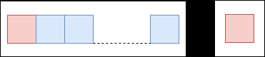

Figure 3

## How to solve a 2xN:

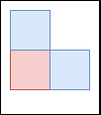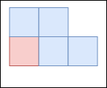2xN is a little bit more complicated, but still not that bad. Essentially you want to make the board look like a staircase (something you could push your friends down if you think they'll beat you at this game) where the bottom layer is always one pip longer than the top layer. This makes a lot more sense if you look at it, so if you're confused to take a gander at figures 4 and 5. This will work all the way up until the very last poison piece where the top row will be of length 0 and the bottom row will be up like one which still adheres to our pattern for solving a 2xN.

Figure 4

Figure 5

## How to solve an NxN:

Solving an end to end board, or a square board, it's just a matter of reducing it to an L shape where the top column and the foot are of equal length. After that you tweedledee-tweedledum with your opponent until you can reduce it down to the single poisoned piece and win. That is to say, if you have a 7 x 7 board, your first move will be to take away the center 6 by 6 square leaving you with the First Column being 7 tall and the bottom row being 7 long joined at the poisoned piece. It's a very similar pattern to solving two pile takeaway. See figure 5 for reference.

## Why do I want to go first?

Now if you've been paying attention, you've likely noticed that in order to win you have to go first on are solved boards. For some this might be intuitive, it is absolutely necessary for this game. You can see this if you use a strategy stealing argument. While I will not formally be proving this here as it is well documented, I will lay out a basic argument for it, and for those interested, you can find further readings in my sources. So, let’s first imagine that we are at any rectangular starting position other than a single poison two piece. Let's then assume that the second player has a winning strategy, we know that this isn't true but let's follow this line of thought for argument's sake. What's Ben say that the first player takes the single chocolate piece from the corner, see the figures below if you get confused. Well, then the second player implementing their strategy we'll take a section of the board that necessarily included that first piece. This begs the question why didn't the first player simply make that move because it was available to them. And since player to a winning strategy would have been available to player one, player one must have instead had the winning strategy.

# Special Notation

Throughout this paper I will be referring to various chomp boards, and because I don't hate my audience or myself I have done my best to find a clear way to represent this information. As such I have found three helpful ways to represent a board. These forms are pictographic, long form, and condensed form. They each fill specific roles and purposes, and in order to understand the rest of the paper you have to understand this notation.

## Pictographic:

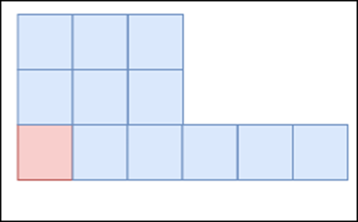This one is the most straightforward and visually intuitive, the pictographic form is the form that the figures have been taking throughout this paper up until this point. It is literally a picture of the board where the poison square is indicated by the red space.

Figure

## Long Form

The long form is less intuitive than pictographic but still more so than the condensed form. The long form is a series of numbers within parenthesis where each number represents the height of a column of blocks. For instance, figure six would be represented as: (3, 3, 3, 1, 1, 1). This is still a much shorter form then pictographic can be as larger boards when represented pictographically take up a lot of space on paper and are very unwieldy to work with.

## Condensed Form

Since my primary training is as a computer scientist, I am very lazy and like to represent data as concisely as I can, and the long form was just, well, too long for my tastes. I needed it to be smaller. And I discovered during my data mining process something that once I say it will be very obvious but took me a minute to realize. As you move from left to right across the board the height of each individual column can only be the same size or smaller. And this makes sense given the way the game is played but it lends itself to a very mean way to compress a board. You can also see this pattern emerge within the long form where it will be a series of one number followed by a series of a smaller number and so on all the way to the end of the board where there's an infinite number of trailing zeros that we don't care about. Because of this instead of typing the height of each column A numerous amount of times, I can simply express how many blocks of that height that there are. This makes more sense with an example, sofa go back to Figure 6 we can see that in its condensed form it would be [3, 0, 3] because there are three 3's, zero 2's, and three 1's. Now in order to differentiate the condensed form from the loan form instead of enclosing it within parenthesis, we enclose it within brackets.

In short, the pictographic form is literally a picture, the long-form is a series of heights enclosed within parentheses, and the condensed form is the quantity of each height enclosed within brackets.

# Partial Solutions of 3 x N

# Special Cases under [2, k, 2]